Email: | Phone:   
LinkedIn: | GitHub:

**Experience**  
 -

**Projects**  
 -

**Skills**

**Education**  
 -

**Shadulla Khurshid Alam Shaikh** Email: sshadulla22@gmail.com | Phone: 09833755209 LinkedIn: xasasa | GitHub: dfdfdfdff

**Experience**  
- dfdfdfdfdf

**Projects**  
 - dfdffdfdf

**Skills**   
 dfdfdfdf

**Education**  
 - asbsddfdfdsfsdf

**Shadulla Khurshid Alam Shaikh** Email: sshadulla22@gmail.com | Phone: 09833755209 LinkedIn: xasasa | GitHub: dfdfdfdff

**Experience**  
- dfdfdfdfdf

**Projects**  
 - dfdffdfdf

**Skills**   
 dfdfdfdf

**Education**  
 - asbsddfdfdsfsdf

**Shadulla Khurshid Alam Shaikh** Email: sshadulla22@gmail.com | Phone: 09833755209 LinkedIn: xasasa | GitHub: dfdfdfdff

**Experience**  
- dfdfdfdfdf

**Projects**  
 - dfdffdfdf

**Skills**   
 dfdfdfdf

**Education**  
 - asbsddfdfdsfsdf

Email: | Phone:   
LinkedIn: | GitHub:

**Experience**  
 -

**Projects**  
 -

**Skills**

**Education**  
 -

**Shadulla Khurshid Alam Shaikh** Email: sshadulla22@gmail.com   
Phone: 09833755209   
**Education**   
 BE   
**Experience**   
 2.5   
**Skills**   
 html css

Email: | Phone:   
LinkedIn: | GitHub:

**Experience**  
 -

**Projects**  
 -

**Skills**

**Education**  
 -

**Shadulla Khurshid Alam Shaikh** Email: sshadulla22@gmail.com | Phone: 09833755209 LinkedIn: xasasa | GitHub: dfdfdfdff

**Experience**  
- dfdfdfdfdf

**Projects**  
 - dfdffdfdf

**Skills**   
 dfdfdfdf

**Education**  
 - asbsddfdfdsfsdf

**Shadulla Khurshid Alam Shaikh** Email: sshadulla22@gmail.com | Phone: 09833755209 LinkedIn: xasasa | GitHub: dfdfdfdff

**Experience**  
- dfdfdfdfdf

**Projects**  
 - dfdffdfdf

**Skills**   
 dfdfdfdf

**Education**  
 - asbsddfdfdsfsdf

**Shadulla Khurshid Alam Shaikh** Email: sshadulla22@gmail.com | Phone: 09833755209 LinkedIn: xasasa | GitHub:   
**Experience**   
**Projects**   
**Skills**

**Education**

**Shadulla Khurshid Alam Shaikh** Email: sshadulla22@gmail.com | Phone: 09833755209 LinkedIn: xasasa | GitHub: dfdfdfdff

**Experience**  
- dfdfdfdfdf

**Projects**  
 - dfdffdfdf

**Skills**   
 dfdfdfdf

**Education**  
 - asbsddfdfdsfsdf

**Shadulla Khurshid Alam Shaikh** Email: sshadulla22@gmail.com | Phone: 09833755209 LinkedIn: xasasa | GitHub:   
**Experience**   
**Projects**   
**Skills**

**Education**

Email: | Phone:   
LinkedIn: | GitHub:

**Experience**  
 -

**Projects**  
 -

**Skills**

**Education**  
 -

**Shadulla Khurshid Alam Shaikh** Email: sshadulla22@gmail.com | Phone: 09833755209 LinkedIn: xasasa | GitHub: dfdfdfdff

**Experience**  
- dfdfdfdfdf

**Projects**  
 - dfdffdfdf

**Skills**   
 dfdfdfdf

**Education**  
 - asbsddfdfdsfsdf

**Shadulla Khurshid Alam Shaikh** Email: sshadulla22@gmail.com | Phone: 09833755209 LinkedIn: xasasa | GitHub:   
**Experience**   
**Projects**   
**Skills**

**Education**

**Shadulla Khurshid Alam Shaikh** Email: sshadulla22@gmail.com   
Phone: 09833755209   
**Education**   
 BE   
**Experience**   
 2.5   
**Skills**   
 html css

Email: | Phone:   
LinkedIn: | GitHub:

**Experience**  
 -

**Projects**  
 -

**Skills**

**Education**  
 -

**Shadulla Khurshid Alam Shaikh** Email: sshadulla22@gmail.com | Phone: 09833755209 LinkedIn: xasasa | GitHub: dfdfdfdff

**Experience**  
- dfdfdfdfdf

**Projects**  
 - dfdffdfdf

**Skills**   
 dfdfdfdf

**Education**  
 - asbsddfdfdsfsdf

**Shadulla Khurshid Alam Shaikh** Email: sshadulla22@gmail.com | Phone: 09833755209 LinkedIn: xasasa | GitHub: dfdfdfdff

**Experience**  
- dfdfdfdfdf

**Projects**  
 - dfdffdfdf

**Skills**   
 dfdfdfdf

**Education**  
 - asbsddfdfdsfsdf

**Shadulla Khurshid Alam Shaikh** Email: sshadulla22@gmail.com | Phone: 09833755209 LinkedIn: xasasa | GitHub:   
**Experience**   
**Projects**   
**Skills**

**Education**

**Shadulla Shaikh**   
**AI’s Kalsekar Technical Campus, Navi Mumbai**

Navi Mumbai, Taloja - 410208, Maharashtra, India

+91-9833755209 [sshadulla22@gmail.com](mailto:sshadulla22@gmail.com)

[https://www.linkedin.com/in/shadulla-shaikh-2a3354231/](http://https://www.linkedin.com/in/shadulla-shaikh-2a3354231/) **Experience**

•[https://github.com/sshadulla22](http://https://github.com/sshadulla22)

**1.** Aug 2023 – Nov 2023 | **Envee Wheeels Pvt. Ltd.** | Web-Developer & Graphic Designer – Remote

Developed and deployed a company website to establish an online presence and enable bike booking for the launch of BULL 007, utilizing cPanel for file management.

Managed Instagram, Facebook, LinkedIn, and X, creating content to boost brand visibility.

Tech Stack: Frontend, SQL, cPanel, Node.js, Figma, Canva

**[Deployed Link](https://envee-intern.netlify.app/)**[: https://envee-intern.netlify.app/](https://envee-intern.netlify.app/)

**2.** Apr 2024 – Sept 2024 | **SoftDigits Pvt. Ltd.** | Web-Developer – Remote

Developed and deployed a website *[startupmela.in for SoftDigits, creating a user-friendly interface to showcase startup-related resources and opportunities.](https://startupmela.in/)*

Optimized for performance and SEO to increase visibility and accessibility.

Tech Stack: HTML, CSS, JavaScript, SQL, and Hostinger for deployment and hosting. **Key Projects**

**1. *[MammoCare Software](https://github.com/sshadulla22/MammoCare_V3)***

*[GitHub Repository: https://github.com/sshadulla22/MammoCareV](https://github.com/sshadulla22/MammoCare_V3)* [3](https://github.com/sshadulla22/MammoCare_V3)

**July 2024 - Oct 2024** *AIKTC/AiCodex Hackathon Project*

MammoCare – Mammogram Image Deblurring, Pectoral Removal, and Tumor Visualization; implemented deblurring, pectoral muscle removal, and **3D/4D tumor visualization**, improving clarity by **40%**.

Integrated **Image Moderatioon AI** and **GPT-3.5 chatbot** for diagnostic assistance.

*Technologies: Python & libraire’s,Streamlit, HTML, CSS,* ***aiXplain***

**Technical & Leadership Skills**

**Programming:** Python & libraries, JavaScript   
**Web Development:** React.js, HTML, CSS, Bootstrap, Tailwind CSS **Database:** SQL   
**Design Tools:** Figma, Canva, Blender, UE5 (3D modeling)   
**Deployment:** Hostinger, GoDaddy (cPanel)   
**Leadership:** Team coordination, project planning, communication

**Courses & Certification’s**

**1. QSpider/JSpider/PSpider:** Web Technologies, React.js, Python, SQL, Mannual Testing **2. ExcelR:** Fundamentals of Full stack Development

**Positions of Responsibility**

*Student Coordinator* at Programmers Club, AIKTC (2024-25).

*Technical Secretary* at AIKTC School Of Engineering & Technology (2023-24). *Student Head* at Programmers Club, AIKTC (2023-24).

*Technical Strategy Assistant* at Google Developer Student Club, AIKTC (2022-23).

**Achievements/Awards**

Secured *[1stRank out of 200+ teams](https://www.linkedin.com/feed/update/urn:li:activity:7254102419851149313/)* in AiCodex **Intercollegiate Hackathon**, sponsored by aixplain (US-based MNC) and organized by M.H. Saboo Siddik College of Engineering, Mumbai (2024-25).

**Education**

Nov 2021 – June 2025 **AI’s Kalsekar Technical Campus**, Navi Mumbai

Computer Science & Engineering | CGPI – 7.82

June 2020 – Apr 2021 **M.H. Saboo Siddik College of Engineering**, Mumbai

12th Board | Science | Marks – 74%

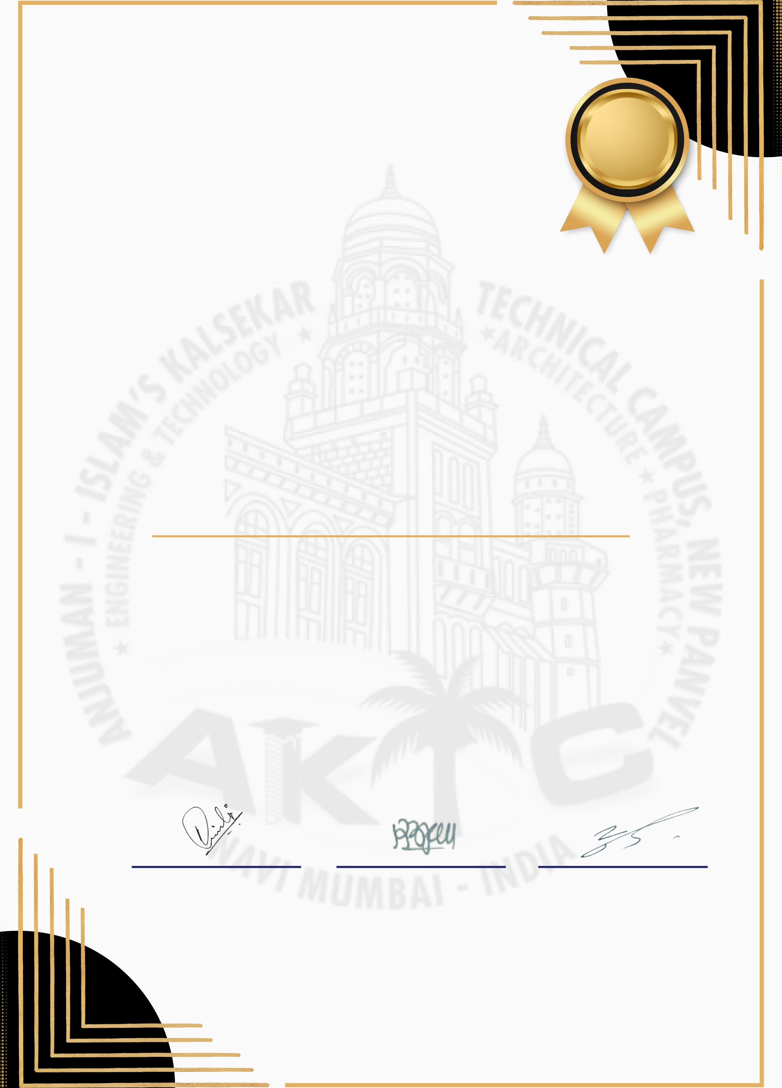

ANJUMAN-I-ISLAM’S   
**KALSEKAR TECHNICAL CAMPUS, PANVEL**

**Council of Students’**   
School of Engineering & Technology Computer Engineering **Batch - 2021-25**

C E R T I F I C A T E

O F A C H I E V E M E N T

Presented to:

MOHD. AMBAR QADRI

In recognition of your exceptional leadership and dedication as **General Secretary** of the **SoET Students' Council** for the academic year **2023-24**. Your commitment to organizing, managing, and successfully executing various events has set a remarkable example of professionalism and teamwork. Your tireless efforts, innovative ideas, and ability to bring students together have made a lasting impact on the council and the student community. We appreciate your outstanding contributions and commend your ability to handle responsibilities with excellence and grace, ensuring the success of every initiative during your tenure.

|  |  |  |
| --- | --- | --- |
| **Dr. Nusrath Junaidi** | **Dr. Rajendra Magar** | **Dr. Ramjan Khatik** |

|  |  |  |
| --- | --- | --- |
| CONTROLLER, COST | DEAN, SOET | DIRECTOR, AIKTC |

**DOI - 14/10/2024**

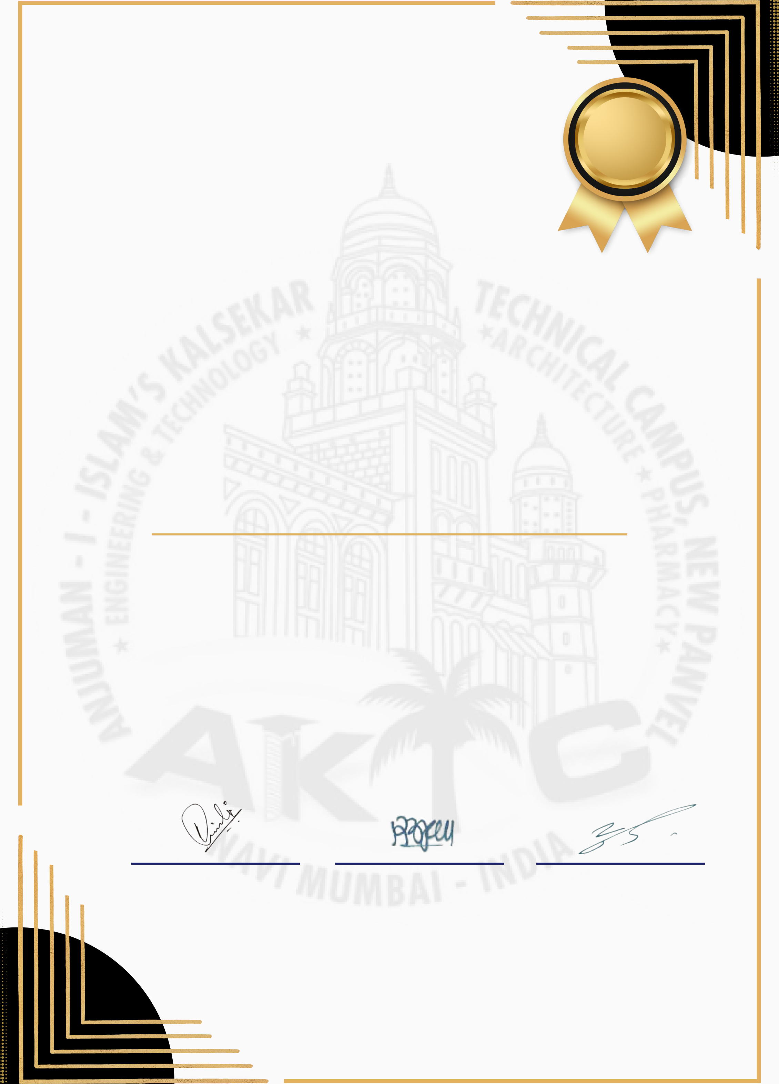

ANJUMAN-I-ISLAM’S   
**KALSEKAR TECHNICAL CAMPUS, PANVEL**

**Council of Students’**   
School of Engineering & Technology Civil Engineering **Batch - 2021-25**

C E R T I F I C A T E

O F A C H I E V E M E N T

Presented to:

MOHD. DANISH KHAN

In recognition of your exceptional leadership and dedication as **Sports Secretary** of the **SoET Students' Council** for the academic year **2023-24**. Your passion for sports and dedication to organizing and overseeing a wide range of athletic events have fostered a vibrant sports culture within our community. Your ability to inspire participation, promote teamwork, and ensure the smooth execution of every sports event has left a lasting impression on both students and staff. We appreciate your commitment to encouraging sportsmanship, promoting a healthy and active lifestyle, and creating memorable sporting events. Your hard work and enthusiasm have truly enriched the student experience.

|  |  |  |
| --- | --- | --- |
| **Dr. Nusrath Junaidi** | **Dr. Rajendra Magar** | **Dr. Ramjan Khatik** |

|  |  |  |
| --- | --- | --- |
| CONTROLLER, COST | DEAN, SOET | DIRECTOR, AIKTC |

**DOI - 14/10/2024**



ANJUMAN-I-ISLAM’S   
**KALSEKAR TECHNICAL CAMPUS, PANVEL**

**Council of Students’**   
School of Engineering & Technology Computer Engineering **Batch - 2021-25**

C E R T I F I C A T E

O F A C H I E V E M E N T

Presented to:

IMAN NAVDEKAR

In recognition of your exceptional leadership and dedication as **Sports Secretary** of the **SoET Students' Council** for the academic year **2023-24**. Your passion for sports and dedication to organizing and overseeing a wide range of athletic events have fostered a vibrant sports culture within our community. Your ability to inspire participation, promote teamwork, and ensure the smooth execution of every sports event has left a lasting impression on both students and staff. We appreciate your commitment to encouraging sportsmanship, promoting a healthy and active lifestyle, and creating memorable sporting events. Your hard work and enthusiasm have truly enriched the student experience.

|  |  |  |
| --- | --- | --- |
| **Dr. Nusrath Junaidi** | **Dr. Rajendra Magar** | **Dr. Ramjan Khatik** |

|  |  |  |
| --- | --- | --- |
| CONTROLLER, COST | DEAN, SOET | DIRECTOR, AIKTC |

**DOI - 14/10/2024**



ANJUMAN-I-ISLAM’S   
**KALSEKAR TECHNICAL CAMPUS, PANVEL**

**Council of Students’**   
School of Engineering & Technology Computer Engineering **Batch - 2021-25**

C E R T I F I C A T E

O F A C H I E V E M E N T

Presented to:

SHADULLA SHAIKH

In recognition of your outstanding leadership and dedication as **Technical Secretary** of the **SoET Students' Council** for the academic year **2023-24**. Your commitment to advancing technical knowledge and encouraging students to embrace innovation has significantly impacted the student community. We are grateful for your efforts in organizing successful technical events and initiatives, which have played a crucial role in enhancing the technical expertise of our students. Your vision and dedication have left a lasting mark on our student body, fostering a spirit of growth and learning.

|  |  |  |
| --- | --- | --- |
| **Dr. Nusrath Junaidi** | **Dr. Rajendra Magar** | **Dr. Ramjan Khatik** |

|  |  |  |
| --- | --- | --- |
| CONTROLLER, COST | DEAN, SOET | DIRECTOR, AIKTC |

**DOI - 14/10/2024**

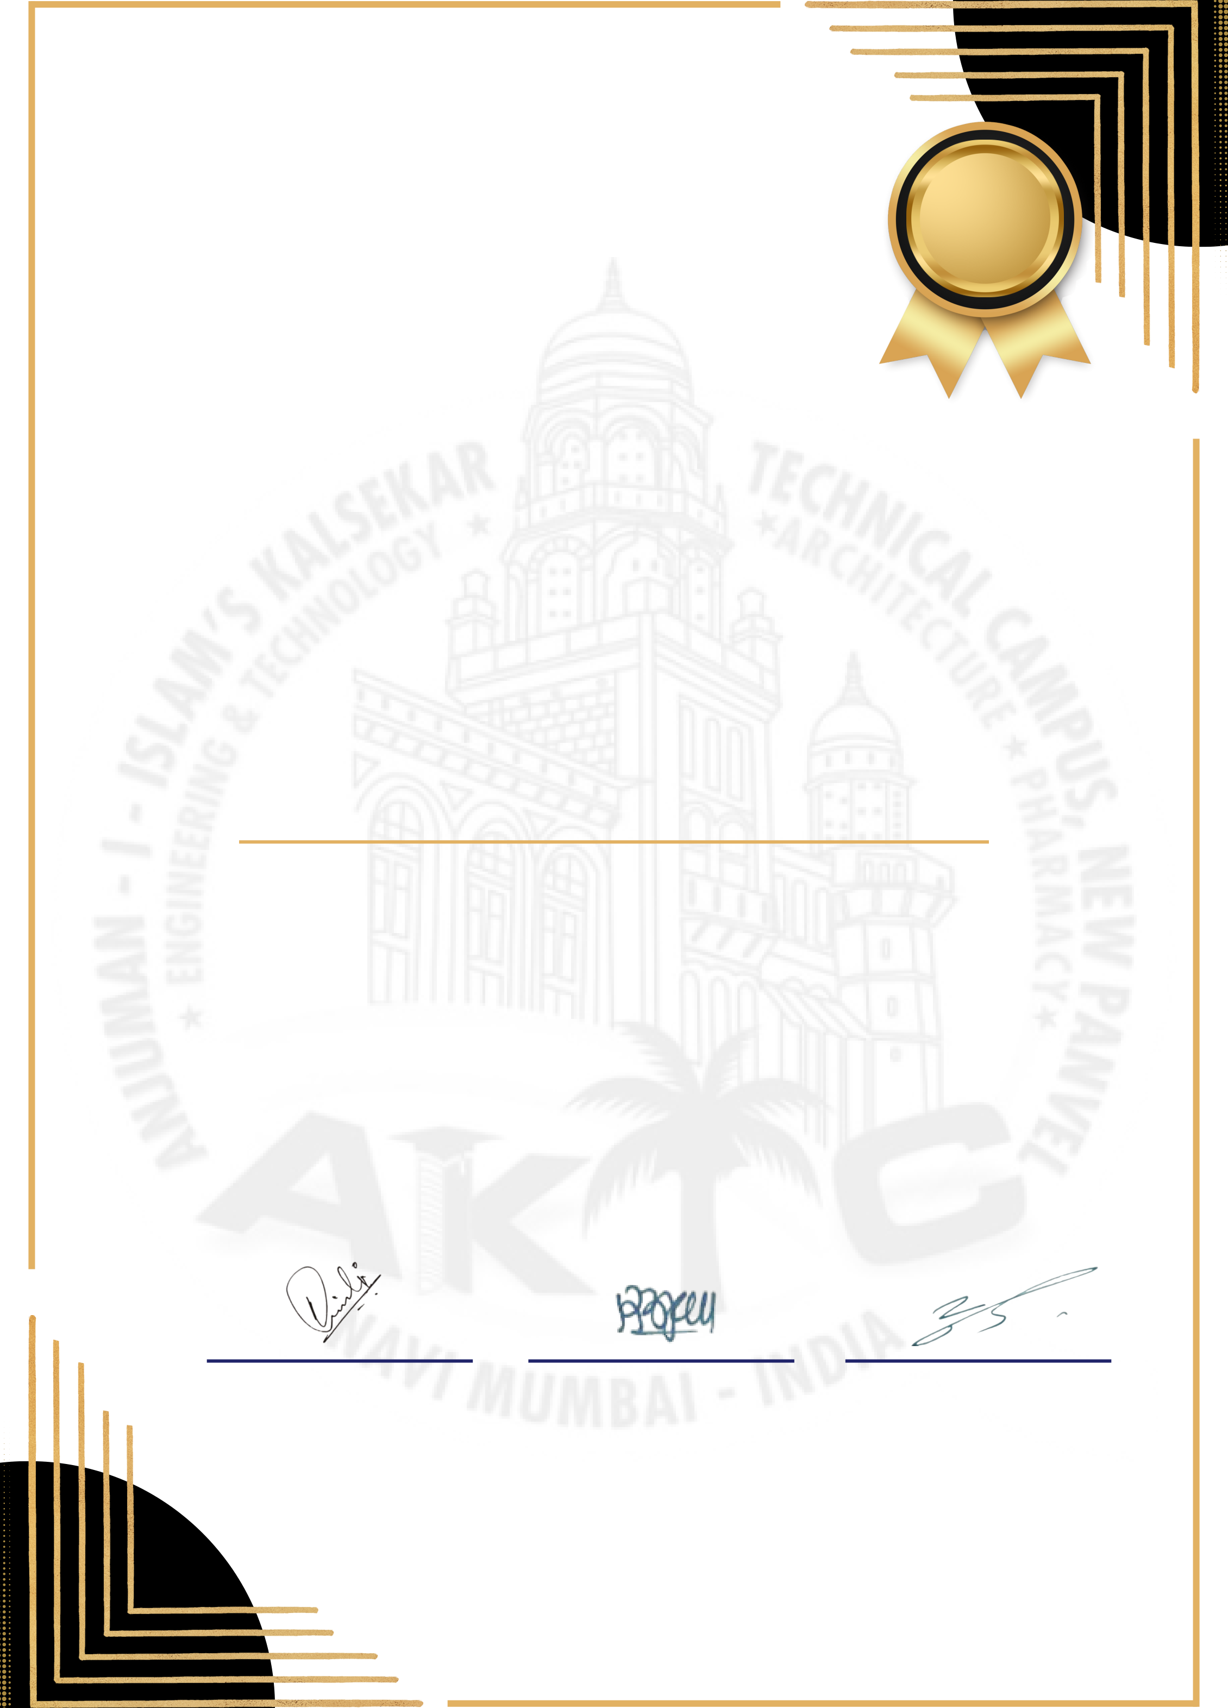

ANJUMAN-I-ISLAM’S   
**KALSEKAR TECHNICAL CAMPUS, PANVEL**

**Council of Students’**   
School of Engineering & Technology BSc-IT **Batch - 2022-25**

C E R T I F I C A T E

O F A C H I E V E M E N T

Presented to:

WAQAR KACHHI

In recognition of your outstanding leadership and dedication as **Technical Secretary** of the **SoET Students' Council** for the academic year **2023-24**. Your commitment to advancing technical knowledge and encouraging students to embrace innovation has significantly impacted the student community. We are grateful for your efforts in organizing successful technical events and initiatives, which have played a crucial role in enhancing the technical expertise of our students. Your vision and dedication have left a lasting mark on our student body, fostering a spirit of growth and learning.

|  |  |  |
| --- | --- | --- |
| **Dr. Nusrath Junaidi** | **Dr. Rajendra Magar** | **Dr. Ramjan Khatik** |

|  |  |  |
| --- | --- | --- |
| CONTROLLER, COST | DEAN, SOET | DIRECTOR, AIKTC |

**DOI - 14/10/2024**

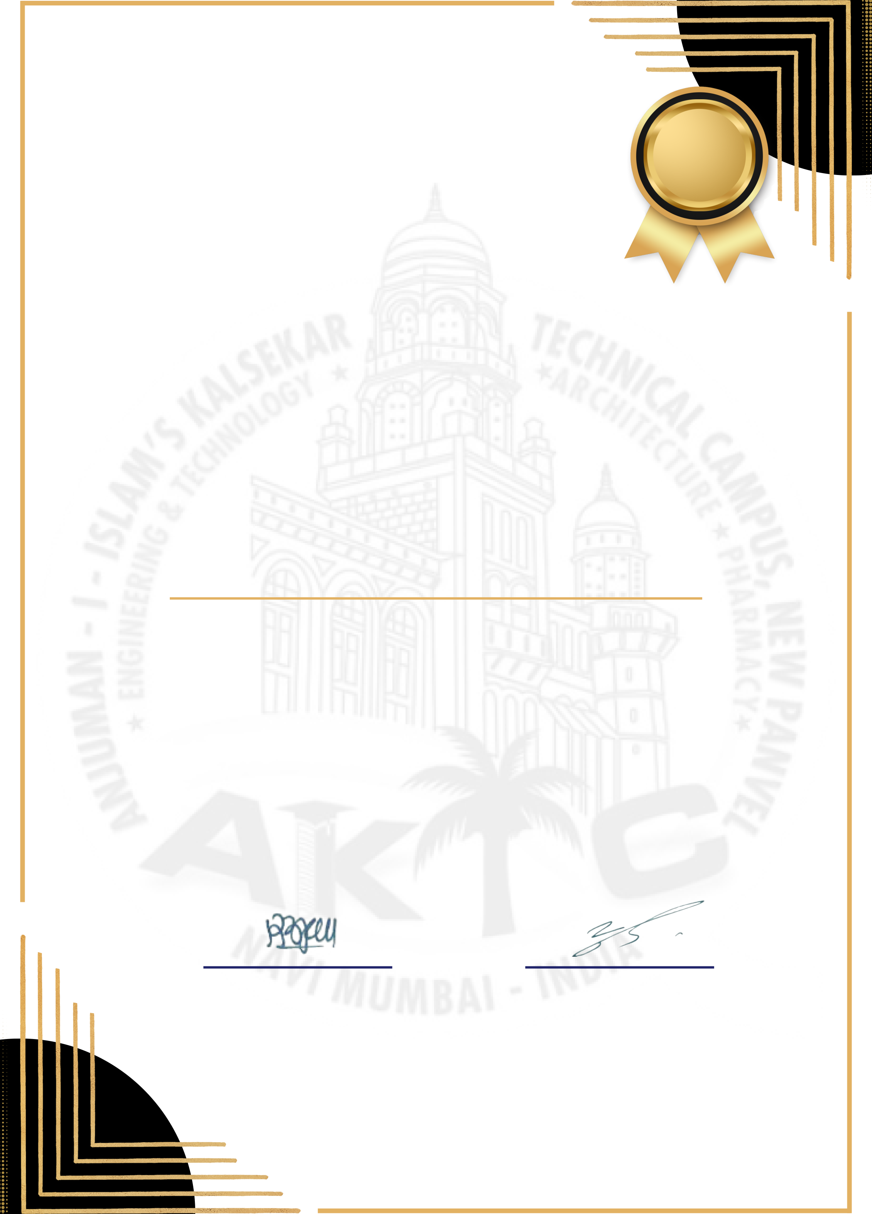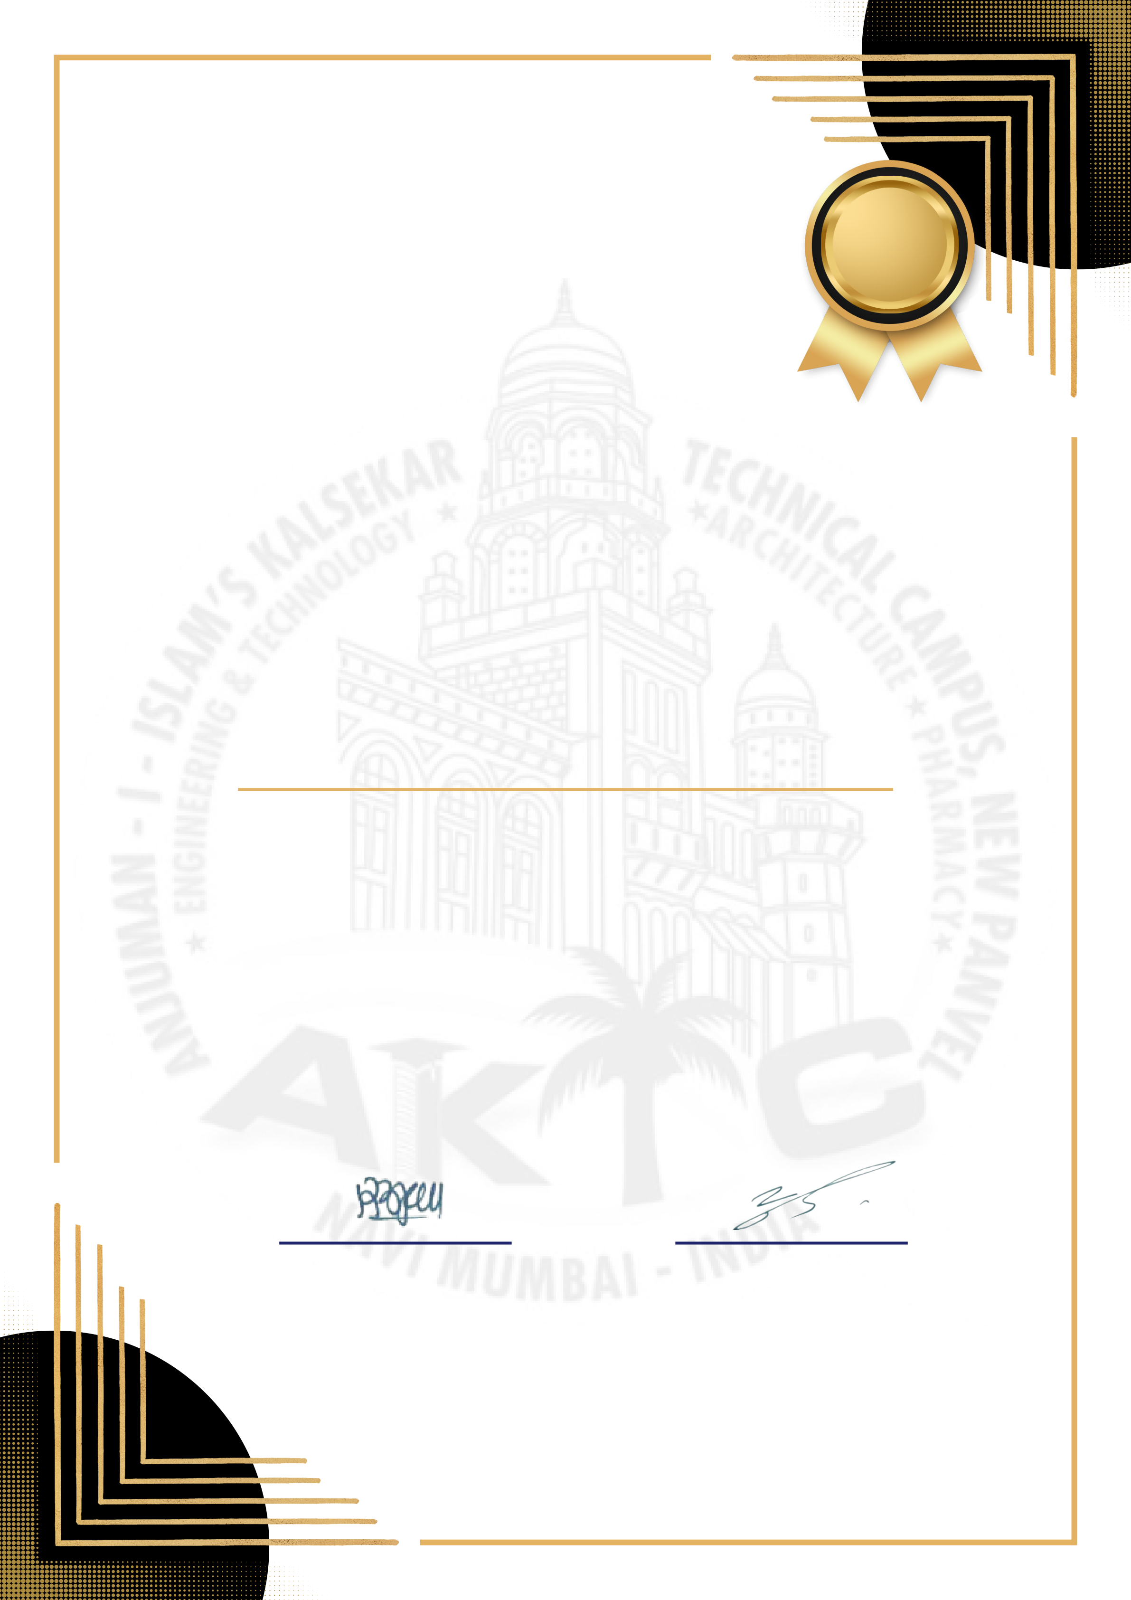

ANJUMAN-I-ISLAM’S   
**KALSEKAR TECHNICAL CAMPUS, PANVEL** School of Engineering & Technology

C E R T I F I C A T E

O F A P P R E C I A T I O N

Presented to:

DR. SHAHBAZ HAQUE

In recognition of your exceptional guidance and support as **COST Advisor** for the academic year 2023-24. Your invaluable mentorship and dedication to fostering a culture of innovation and technical excellence have made a profound impact on the student community. We are deeply appreciative of your efforts in guiding and inspiring students through various technical initiatives and events, which have played a pivotal role in enhancing their skills and knowledge. Your vision and commitment have left an enduring legacy, promoting growth, learning, and a passion for technology among our students.

**Dr. Rajendra Magar**  **Dr. Ramjan Khatik**

DEAN, SOET DIRECTOR, AIKTC



ANJUMAN-I-ISLAM’S   
**KALSEKAR TECHNICAL CAMPUS, PANVEL** School of Engineering & Technology

C E R T I F I C A T E

O F A P P R E C I A T I O N

Presented to:

DR. NUSRATH JUNAIDI

In recognition of your exceptional guidance and support as **COST Controller** for the academic year 2023-24. Your invaluable mentorship and dedication to fostering a culture of innovation and technical excellence have made a profound impact on the student community. We are deeply appreciative of your efforts in guiding and inspiring students through various technical initiatives and events, which have played a pivotal role in enhancing their skills and knowledge. Your vision and commitment have left an enduring legacy, promoting growth, learning, and a passion for technology among our students.

**Dr. Rajendra Magar**  **Dr. Ramjan Khatik**

DEAN, SOET DIRECTOR, AIKTC

Email: | Phone:   
LinkedIn: | GitHub:

**Experience**  
 -

**Projects**  
 -

**Skills**

**Education**  
 -

**Shadulla Khurshid Alam Shaikh** Email: sshadulla22@gmail.com | Phone: 09833755209 LinkedIn: xasasa | GitHub: dfdfdfdff

**Experience**  
- dfdfdfdfdf

**Projects**  
 - dfdffdfdf

**Skills**   
 dfdfdfdf

**Education**  
 - asbsddfdfdsfsdf

**Shadulla Khurshid Alam Shaikh** Email: sshadulla22@gmail.com | Phone: 09833755209 LinkedIn: xasasa | GitHub: dfdfdfdff

**Experience**  
- dfdfdfdfdf

**Projects**  
 - dfdffdfdf

**Skills**   
 dfdfdfdf

**Education**  
 - asbsddfdfdsfsdf

**Shadulla Khurshid Alam Shaikh** Email: sshadulla22@gmail.com | Phone: 09833755209 LinkedIn: xasasa | GitHub:   
**Experience**   
**Projects**   
**Skills**

**Education**

**Shadulla Khurshid Alam Shaikh** Email: sshadulla22@gmail.com | Phone: 09833755209 LinkedIn: xasasa | GitHub:   
**Experience**   
**Projects**   
**Skills**

**Education**

**Shadulla Khurshid Alam Shaikh** Email: sshadulla22@gmail.com   
Phone: 09833755209   
**Education**   
 BE   
**Experience**   
 2.5   
**Skills**   
 html css

Email: | Phone:   
LinkedIn: | GitHub:

**Experience**  
 -

**Projects**  
 -

**Skills**

**Education**  
 -

**Shadulla Khurshid Alam Shaikh** Email: sshadulla22@gmail.com | Phone: 09833755209 LinkedIn: xasasa | GitHub: dfdfdfdff

**Experience**  
- dfdfdfdfdf

**Projects**  
 - dfdffdfdf

**Skills**   
 dfdfdfdf

**Education**  
 - asbsddfdfdsfsdf

**Shadulla Khurshid Alam Shaikh** Email: sshadulla22@gmail.com | Phone: 09833755209 LinkedIn: xasasa | GitHub: dfdfdfdff

**Experience**  
- dfdfdfdfdf

**Projects**  
 - dfdffdfdf

**Skills**   
 dfdfdfdf

**Education**  
 - asbsddfdfdsfsdf

**Shadulla Khurshid Alam Shaikh** Email: sshadulla22@gmail.com | Phone: 09833755209 LinkedIn: xasasa | GitHub:   
**Experience**   
**Projects**   
**Skills**

**Education**

**Shadulla Khurshid Alam Shaikh** Email: sshadulla22@gmail.com | Phone: 09833755209 LinkedIn: xasasa | GitHub: dfdfdfdff

**Experience**  
- dfdfdfdfdf

**Projects**  
 - dfdffdfdf

**Skills**   
 dfdfdfdf

**Education**  
 - asbsddfdfdsfsdf

**Shadulla Khurshid Alam Shaikh** Email: sshadulla22@gmail.com | Phone: 09833755209 LinkedIn: xasasa | GitHub:   
**Experience**   
**Projects**   
**Skills**

**Education**

Email: | Phone:   
LinkedIn: | GitHub:

**Experience**  
 -

**Projects**  
 -

**Skills**

**Education**  
 -

**Shadulla Khurshid Alam Shaikh** Email: sshadulla22@gmail.com | Phone: 09833755209 LinkedIn: xasasa | GitHub: dfdfdfdff

**Experience**  
- dfdfdfdfdf

**Projects**  
 - dfdffdfdf

**Skills**   
 dfdfdfdf

**Education**  
 - asbsddfdfdsfsdf

**Shadulla Khurshid Alam Shaikh** Email: sshadulla22@gmail.com | Phone: 09833755209 LinkedIn: xasasa | GitHub:   
**Experience**   
**Projects**   
**Skills**

**Education**

**Shadulla Khurshid Alam Shaikh** Email: sshadulla22@gmail.com   
Phone: 09833755209   
**Education**   
 BE   
**Experience**   
 2.5   
**Skills**   
 html css

Email: | Phone:   
LinkedIn: | GitHub:

**Experience**  
 -

**Projects**  
 -

**Skills**

**Education**  
 -

**Shadulla Khurshid Alam Shaikh** Email: sshadulla22@gmail.com | Phone: 09833755209 LinkedIn: xasasa | GitHub: dfdfdfdff

**Experience**  
- dfdfdfdfdf

**Projects**  
 - dfdffdfdf

**Skills**   
 dfdfdfdf

**Education**  
 - asbsddfdfdsfsdf

**Shadulla Khurshid Alam Shaikh** Email: sshadulla22@gmail.com | Phone: 09833755209 LinkedIn: xasasa | GitHub: dfdfdfdff

**Experience**  
- dfdfdfdfdf

**Projects**  
 - dfdffdfdf

**Skills**   
 dfdfdfdf

**Education**  
 - asbsddfdfdsfsdf

**Shadulla Khurshid Alam Shaikh** Email: sshadulla22@gmail.com | Phone: 09833755209 LinkedIn: xasasa | GitHub:   
**Experience**   
**Projects**   
**Skills**

**Education**

**Shadulla Shaikh**   
**AI’s Kalsekar Technical Campus, Navi Mumbai**

Navi Mumbai, Taloja - 410208, Maharashtra, India

+91-9833755209 [sshadulla22@gmail.com](mailto:sshadulla22@gmail.com)

[https://www.linkedin.com/in/shadulla-shaikh-2a3354231/](http://https://www.linkedin.com/in/shadulla-shaikh-2a3354231/) **Experience**

•[https://github.com/sshadulla22](http://https://github.com/sshadulla22)

**1.** Aug 2023 – Nov 2023 | **Envee Wheeels Pvt. Ltd.** | Web-Developer & Graphic Designer – Remote

Developed and deployed a company website to establish an online presence and enable bike booking for the launch of BULL 007, utilizing cPanel for file management.

Managed Instagram, Facebook, LinkedIn, and X, creating content to boost brand visibility.

Tech Stack: Frontend, SQL, cPanel, Node.js, Figma, Canva

**[Deployed Link](https://envee-intern.netlify.app/)**[: https://envee-intern.netlify.app/](https://envee-intern.netlify.app/)

**2.** Apr 2024 – Sept 2024 | **SoftDigits Pvt. Ltd.** | Web-Developer – Remote

Developed and deployed a website *[startupmela.in for SoftDigits, creating a user-friendly interface to showcase startup-related resources and opportunities.](https://startupmela.in/)*

Optimized for performance and SEO to increase visibility and accessibility.

Tech Stack: HTML, CSS, JavaScript, SQL, and Hostinger for deployment and hosting. **Key Projects**

**1. *[MammoCare Software](https://github.com/sshadulla22/MammoCare_V3)***

*[GitHub Repository: https://github.com/sshadulla22/MammoCareV](https://github.com/sshadulla22/MammoCare_V3)* [3](https://github.com/sshadulla22/MammoCare_V3)

**July 2024 - Oct 2024** *AIKTC/AiCodex Hackathon Project*

MammoCare – Mammogram Image Deblurring, Pectoral Removal, and Tumor Visualization; implemented deblurring, pectoral muscle removal, and **3D/4D tumor visualization**, improving clarity by **40%**.

Integrated **Image Moderatioon AI** and **GPT-3.5 chatbot** for diagnostic assistance.

*Technologies: Python & libraire’s,Streamlit, HTML, CSS,* ***aiXplain***

**Technical & Leadership Skills**

**Programming:** Python & libraries, JavaScript   
**Web Development:** React.js, HTML, CSS, Bootstrap, Tailwind CSS **Database:** SQL   
**Design Tools:** Figma, Canva, Blender, UE5 (3D modeling)   
**Deployment:** Hostinger, GoDaddy (cPanel)   
**Leadership:** Team coordination, project planning, communication

**Courses & Certification’s**

**1. QSpider/JSpider/PSpider:** Web Technologies, React.js, Python, SQL, Mannual Testing **2. ExcelR:** Fundamentals of Full stack Development

**Positions of Responsibility**

*Student Coordinator* at Programmers Club, AIKTC (2024-25).

*Technical Secretary* at AIKTC School Of Engineering & Technology (2023-24). *Student Head* at Programmers Club, AIKTC (2023-24).

*Technical Strategy Assistant* at Google Developer Student Club, AIKTC (2022-23).

**Achievements/Awards**

Secured *[1stRank out of 200+ teams](https://www.linkedin.com/feed/update/urn:li:activity:7254102419851149313/)* in AiCodex **Intercollegiate Hackathon**, sponsored by aixplain (US-based MNC) and organized by M.H. Saboo Siddik College of Engineering, Mumbai (2024-25).

**Education**

Nov 2021 – June 2025 **AI’s Kalsekar Technical Campus**, Navi Mumbai

Computer Science & Engineering | CGPI – 7.82

June 2020 – Apr 2021 **M.H. Saboo Siddik College of Engineering**, Mumbai

12th Board | Science | Marks – 74%



ANJUMAN-I-ISLAM’S   
**KALSEKAR TECHNICAL CAMPUS, PANVEL**

**Council of Students’**   
School of Engineering & Technology Computer Engineering **Batch - 2021-25**

C E R T I F I C A T E

O F A C H I E V E M E N T

Presented to:

MOHD. AMBAR QADRI

In recognition of your exceptional leadership and dedication as **General Secretary** of the **SoET Students' Council** for the academic year **2023-24**. Your commitment to organizing, managing, and successfully executing various events has set a remarkable example of professionalism and teamwork. Your tireless efforts, innovative ideas, and ability to bring students together have made a lasting impact on the council and the student community. We appreciate your outstanding contributions and commend your ability to handle responsibilities with excellence and grace, ensuring the success of every initiative during your tenure.

|  |  |  |
| --- | --- | --- |
| **Dr. Nusrath Junaidi** | **Dr. Rajendra Magar** | **Dr. Ramjan Khatik** |

|  |  |  |
| --- | --- | --- |
| CONTROLLER, COST | DEAN, SOET | DIRECTOR, AIKTC |

**DOI - 14/10/2024**



ANJUMAN-I-ISLAM’S   
**KALSEKAR TECHNICAL CAMPUS, PANVEL**

**Council of Students’**   
School of Engineering & Technology Civil Engineering **Batch - 2021-25**

C E R T I F I C A T E

O F A C H I E V E M E N T

Presented to:

MOHD. DANISH KHAN

In recognition of your exceptional leadership and dedication as **Sports Secretary** of the **SoET Students' Council** for the academic year **2023-24**. Your passion for sports and dedication to organizing and overseeing a wide range of athletic events have fostered a vibrant sports culture within our community. Your ability to inspire participation, promote teamwork, and ensure the smooth execution of every sports event has left a lasting impression on both students and staff. We appreciate your commitment to encouraging sportsmanship, promoting a healthy and active lifestyle, and creating memorable sporting events. Your hard work and enthusiasm have truly enriched the student experience.

|  |  |  |
| --- | --- | --- |
| **Dr. Nusrath Junaidi** | **Dr. Rajendra Magar** | **Dr. Ramjan Khatik** |

|  |  |  |
| --- | --- | --- |
| CONTROLLER, COST | DEAN, SOET | DIRECTOR, AIKTC |

**DOI - 14/10/2024**



ANJUMAN-I-ISLAM’S   
**KALSEKAR TECHNICAL CAMPUS, PANVEL**

**Council of Students’**   
School of Engineering & Technology Computer Engineering **Batch - 2021-25**

C E R T I F I C A T E

O F A C H I E V E M E N T

Presented to:

IMAN NAVDEKAR

In recognition of your exceptional leadership and dedication as **Sports Secretary** of the **SoET Students' Council** for the academic year **2023-24**. Your passion for sports and dedication to organizing and overseeing a wide range of athletic events have fostered a vibrant sports culture within our community. Your ability to inspire participation, promote teamwork, and ensure the smooth execution of every sports event has left a lasting impression on both students and staff. We appreciate your commitment to encouraging sportsmanship, promoting a healthy and active lifestyle, and creating memorable sporting events. Your hard work and enthusiasm have truly enriched the student experience.

|  |  |  |
| --- | --- | --- |
| **Dr. Nusrath Junaidi** | **Dr. Rajendra Magar** | **Dr. Ramjan Khatik** |

|  |  |  |
| --- | --- | --- |
| CONTROLLER, COST | DEAN, SOET | DIRECTOR, AIKTC |

**DOI - 14/10/2024**



ANJUMAN-I-ISLAM’S   
**KALSEKAR TECHNICAL CAMPUS, PANVEL**

**Council of Students’**   
School of Engineering & Technology Computer Engineering **Batch - 2021-25**

C E R T I F I C A T E

O F A C H I E V E M E N T

Presented to:

SHADULLA SHAIKH

In recognition of your outstanding leadership and dedication as **Technical Secretary** of the **SoET Students' Council** for the academic year **2023-24**. Your commitment to advancing technical knowledge and encouraging students to embrace innovation has significantly impacted the student community. We are grateful for your efforts in organizing successful technical events and initiatives, which have played a crucial role in enhancing the technical expertise of our students. Your vision and dedication have left a lasting mark on our student body, fostering a spirit of growth and learning.

|  |  |  |
| --- | --- | --- |
| **Dr. Nusrath Junaidi** | **Dr. Rajendra Magar** | **Dr. Ramjan Khatik** |

|  |  |  |
| --- | --- | --- |
| CONTROLLER, COST | DEAN, SOET | DIRECTOR, AIKTC |

**DOI - 14/10/2024**



ANJUMAN-I-ISLAM’S   
**KALSEKAR TECHNICAL CAMPUS, PANVEL**

**Council of Students’**   
School of Engineering & Technology BSc-IT **Batch - 2022-25**

C E R T I F I C A T E

O F A C H I E V E M E N T

Presented to:

WAQAR KACHHI

In recognition of your outstanding leadership and dedication as **Technical Secretary** of the **SoET Students' Council** for the academic year **2023-24**. Your commitment to advancing technical knowledge and encouraging students to embrace innovation has significantly impacted the student community. We are grateful for your efforts in organizing successful technical events and initiatives, which have played a crucial role in enhancing the technical expertise of our students. Your vision and dedication have left a lasting mark on our student body, fostering a spirit of growth and learning.

|  |  |  |
| --- | --- | --- |
| **Dr. Nusrath Junaidi** | **Dr. Rajendra Magar** | **Dr. Ramjan Khatik** |

|  |  |  |
| --- | --- | --- |
| CONTROLLER, COST | DEAN, SOET | DIRECTOR, AIKTC |

**DOI - 14/10/2024**



ANJUMAN-I-ISLAM’S   
**KALSEKAR TECHNICAL CAMPUS, PANVEL** School of Engineering & Technology

C E R T I F I C A T E

O F A P P R E C I A T I O N

Presented to:

DR. SHAHBAZ HAQUE

In recognition of your exceptional guidance and support as **COST Advisor** for the academic year 2023-24. Your invaluable mentorship and dedication to fostering a culture of innovation and technical excellence have made a profound impact on the student community. We are deeply appreciative of your efforts in guiding and inspiring students through various technical initiatives and events, which have played a pivotal role in enhancing their skills and knowledge. Your vision and commitment have left an enduring legacy, promoting growth, learning, and a passion for technology among our students.

**Dr. Rajendra Magar**  **Dr. Ramjan Khatik**

DEAN, SOET DIRECTOR, AIKTC



ANJUMAN-I-ISLAM’S   
**KALSEKAR TECHNICAL CAMPUS, PANVEL** School of Engineering & Technology

C E R T I F I C A T E

O F A P P R E C I A T I O N

Presented to:

DR. NUSRATH JUNAIDI

In recognition of your exceptional guidance and support as **COST Controller** for the academic year 2023-24. Your invaluable mentorship and dedication to fostering a culture of innovation and technical excellence have made a profound impact on the student community. We are deeply appreciative of your efforts in guiding and inspiring students through various technical initiatives and events, which have played a pivotal role in enhancing their skills and knowledge. Your vision and commitment have left an enduring legacy, promoting growth, learning, and a passion for technology among our students.

**Dr. Rajendra Magar**  **Dr. Ramjan Khatik**

DEAN, SOET DIRECTOR, AIKTC